Software Requirements Specification

for

StuddyBuddies
Version 1.0 approved
Prepared by Cyril Agbewali-Koku, Andrew Bobay, Alex Higgins, Kelvin Nana Gyebi, Ryan Bowley, Ryan Hallett, Zachary Bailey
University of Maine, Class COS420, Team Ants
October 2nd 2026
Table of Contents
1. Introduction 1
1.1 Purpose 1
1.2 Document Conventions 1
1.3 Intended Audience and Reading Suggestions 1
1.4 Product Scope 1
1.5 References 1
2. Overall Description 2
2.1 Product Perspective 2
2.2 Product Functions 2
2.3 User Classes and Characteristics 2
2.4 Operating Environment 2
2.5 Design and Implementation Constraints 2
2.6 User Documentation 3
2.7 Assumptions and Dependencies 3
3. External Interface Requirements 3
3.1 User Interfaces 3
3.2 Hardware Interfaces 5
3.3 Software Interfaces 5
3.4 Communications Interfaces 5
4. System Features 6
4.1 Instructor Group Management 6
4.2 Text-Based Chat Communication 7
5. Other Nonfunctional Requirements 9
5.1 Performance Requirements 9
5.2 Safety Requirements 9
5.3 Security Requirements 9
5.4 Software Quality Attributes 10
5.5 Business Rules 10
6. Other Requirements 10

Revision History
Name | Date | Reason For Changes | Version
Ryan Hallett | 10/15/26 | Responding to initial feedback from Greg | 1.1
Cyril A. | 10/22/26 | Making changes to section 1&2 | 1.2
Cyril A. | 10/22/26 | Edited section 2.7 to match our work | 1.2.1
Alex H. | 10/26/26 | Finalized UI section | 1.3.1

Introduction

Purpose
This document is a comprehensive requirements specification for the first release of StudyBuddies. It contains detailed information about the system's features

Document Conventions
This Document was created based on the IEEE template for System Requirement
Specification Documents.

Intended Audience and Reading Suggestions
This document is intended for developers, the project manager, designers, and users. It is organized by system requirements and provides a well structured overview of the StudyBuddies software

Product Scope
StudyBuddies is a group-matching application that helps instructors create study and reflection groups for their classes. Reflection groups can provide this support, but organizing productive groups can be difficult and time-consuming for instructors and students alike. StudyBuddies gives instructors a path to help students by letting them create a server for each class, share a join link, and run a matching algorithm on student survey responses to form groups of 3–5 people. This aims to make the process of forming and managing reflection groups easier for both instructors and students.

References
StudyBuddies Team GitHub Link: https://github.com/COS420-F25/F26-Group-A.git

Overall Description

Product Perspective
StudyBuddies is being developed as a tool which assists instructors in making reflection groups to support student learning. Studybuddies will be built with Astro.js to deliver server rendered pages which will be fast to load. The group matching algorithm is a deterministic python matcher that runs server-side and produces group proposals based on student survey data. Studybuddies is a new tool being built for instructors and students who want a structured way to manage class groups.

Product Functions
Server creation and management
- Create Server: Allows the instructor to create a server for a class they teach.
- Share Join Link: Generates a link that the instructor can share with students to join the server.
- Manage Groups: Allows the instructor to view active groups, manage membership, and answer student questions.

Student Survey
- Join Server: Allows students to join a class server via the instructor's shared link.
- Fill Out Survey: Allows students to specify their weekly availability, interests, and group preferences (desired or undesired group members).

Group matching and review
- Run Matcher: Allows the instructor to run the matching algorithm on submitted surveys to generate a group proposal.
- Review Proposal: Allows the instructor to view proposed groups before approving.
- Edit Groups: Allows the instructor to move or swap students between proposed groups.
- Approve and Publish: Allows the instructor to approve the final groupings and publish them to students.

Group Space
- View Group: Allows students to see their assigned group members and meeting times after publication.
- Group Collaboration: Provides a shared space for group members to communicate.

User Classes and Characteristics
The application is created for two user classes:

Instructors are faculty or teaching staff who create and manage class servers. They are given features including: server creation, join link generation, running the matcher, reviewing group proposals with editing groups, and approving and publishing final groupings. They can also manage active groups and answer student questions through the group space. Instructors are the only users who can see demographic data during the review step.

Students are enrolled members of a class who join a server via a shared link. They are given features including: filling out the survey (availability, interests, and group preferences) and viewing their assigned group after publication. Students can see their group members' names and meeting times, and can use the group space to communicate with their group.

Operating Environment
Studybuddies will be built using Astro and will be accessible in all web browsers.

Design and Implementation Constraints
StudyBuddies will contain security systems to protect student data, since users will be providing personal information including availability schedules, interests, and demographic data for the matching process. Currently the design of the matching algorithm will be deterministic, meaning the same inputs will always produce the same groups. Demographic data will only be available to the instructor when they are reviewing Group formation. Group sizes are constrained to 3–5 members, and nothing reaches students until the instructor explicitly approves the groupings.

User Documentation
User documentation will include an in-app onboarding guide for instructors that walks through creating a server, sharing the join link, and running the matching process. Students will have a help section explaining how to fill out the survey and navigate the group space.

Assumptions and Dependencies
This specification assumes that all students and instructors have access to updated browsers and stable internet connection. Also we assume that instructors will be able to distribute the join link through their own channels, preferably, email.

External Interface Requirements

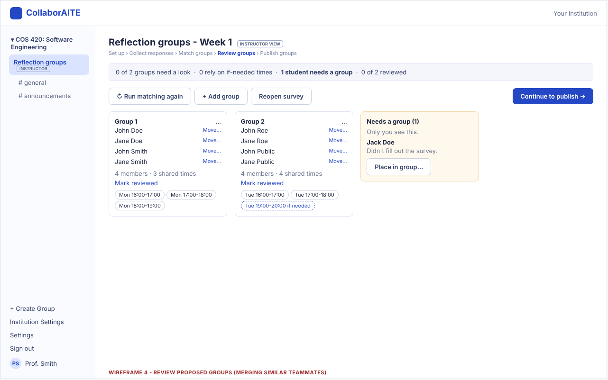
User Interfaces

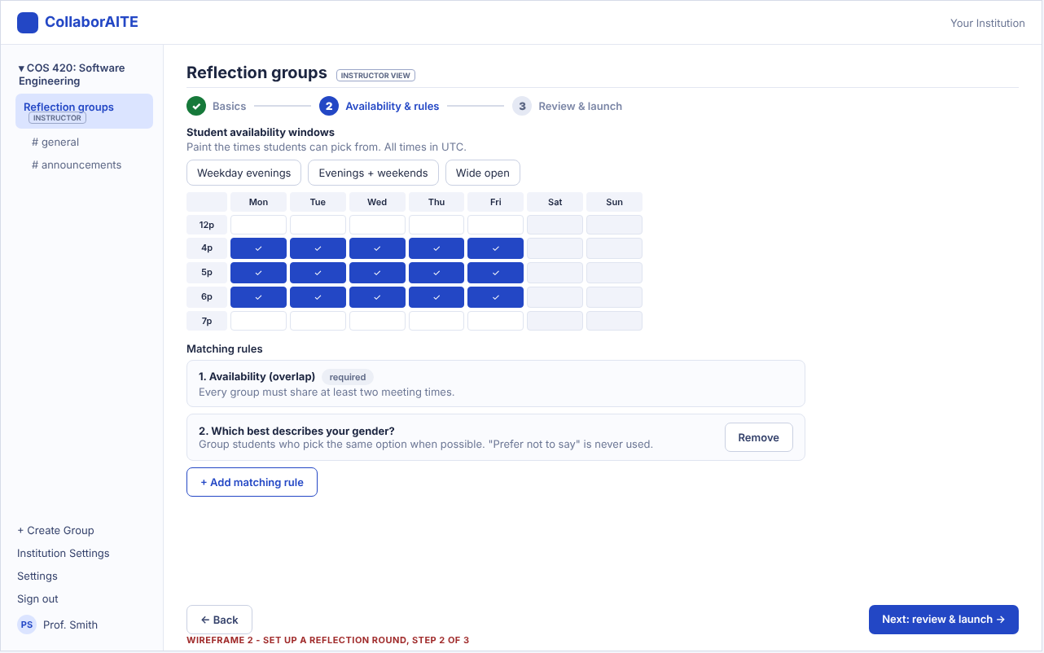

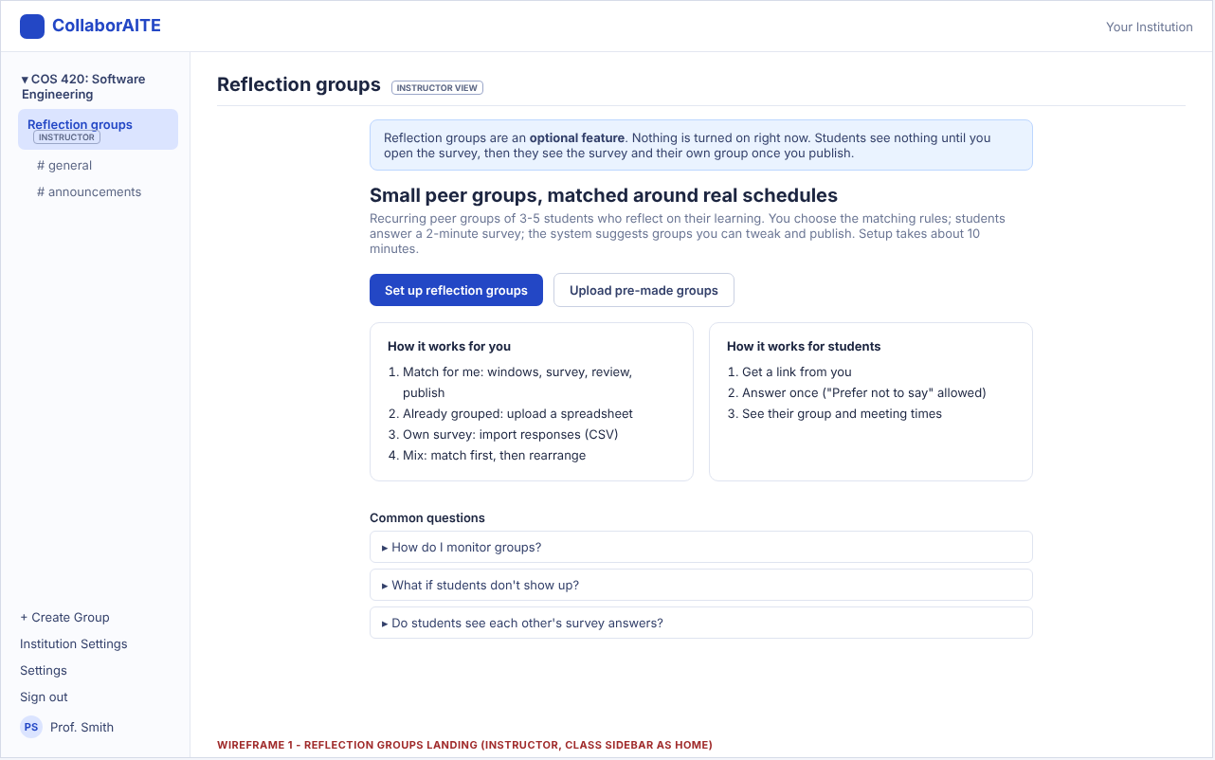

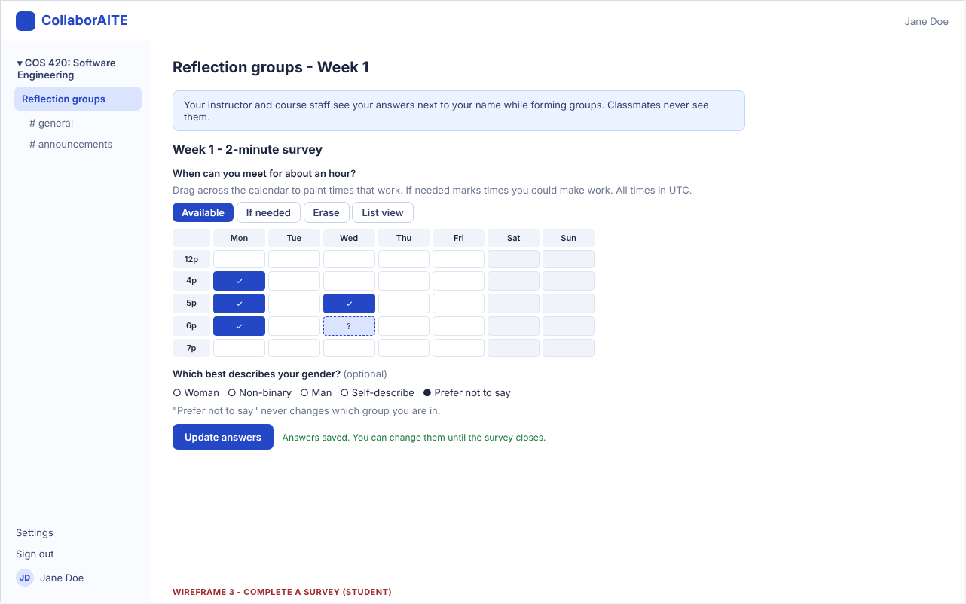

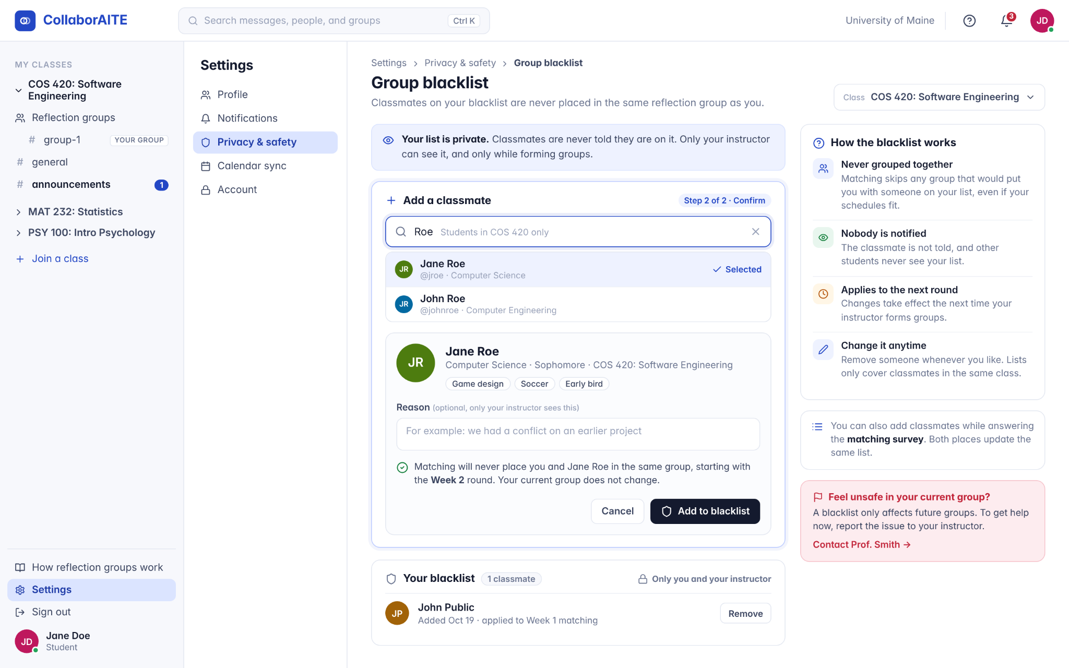

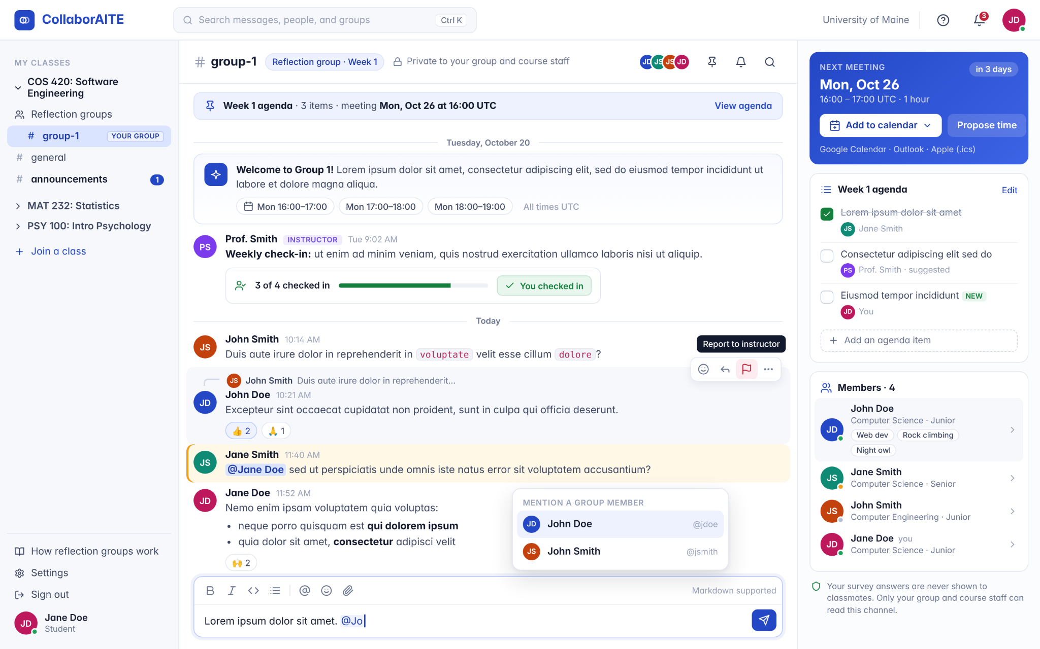
Page 1:Page to review proposed groups
Page 2: Step 2 of a page to set up reflection group
Page 3:Landing page
Page 4:student survey page
Page 5:blacklist page
Page 6:text channel

Hardware Interfaces
<Describe the logical and physical characteristics of each interface between the software product and the hardware components of the system. This may include the supported device types, the nature of the data and control interactions between the software and the hardware, and communication protocols to be used.>

Software Interfaces
<Describe the connections between this product and other specific software components (name and version), including databases, operating systems, tools, libraries, and integrated commercial components. Identify the data items or messages coming into the system and going out and describe the purpose of each. Describe the services needed and the nature of communications. Refer to documents that describe detailed application programming interface protocols. Identify data that will be shared across software components. If the data sharing mechanism must be implemented in a specific way (for example, use of a global data area in a multitasking operating system), specify this as an implementation constraint.>

Communications Interfaces
<Describe the requirements associated with any communications functions required by this product, including e-mail, web browser, network server communications protocols, electronic forms, and so on. Define any pertinent message formatting. Identify any communication standards that will be used, such as FTP or HTTP. Specify any communication security or encryption issues, data transfer rates, and synchronization mechanisms.>

System Features

Instructor Group Management
4.1.1 Description and Priority
StudyBuddies allows instructors to create servers that provide a platform for other students to engage in reflection groups. After taking the survey, an algorithm sorts the students into groups depending on the results; see Section 4.3. Instructors will be able to see any conflicts between students, such as interests and availability. Then instructors can edit the groups as they see fit. This feature is of high priority as instructors need to be able to manage the group after creation. This will benefit students and instructors, as mistakes, incidents, and life can happen, and being able to make adjustments is important.
4.1.2 Stimulus/Response Sequences

One user forgets to block another user in the group-making process
Server Owner can remove/add one of them to another group

The Server Owner uses the system for multiple classes
The Server Owner can switch between classes

4.1.3 Functional Requirements
- The system shall allow the instructor to create a server
- The system shall allow the instructor to create one or more groups
- The system shall allow the instructor to invite students to join the server
- The system shall allow the instructor to add students to groups, remove students from groups and move students between groups
- The system shall require the instructor to approve the group assignments after being sorted.
- The system shall allow the instructor to view all content from every group in the server
- The system shall restrict access to other students’ survey results to the instructor
- The system shall allow the instructor to edit the server settings
- The system shall allow the instructor to send messages to every group in the server
- The system shall allow the instructor to approve, modify, and publish instructor-created reflection groups.
- The system shall allow students to view private group information for reflection groups in which they are members.
- The system shall automatically update group membership for every student whenever the instructor modifies group assignments

Text-Based Chat Communication
4.2.1 Description and Priority
Text-Based Chat Communication allows students to communicate with both their peers and instructors. The primary group chats where the communication happens are called group threads. In group threads, users can send messages that can be seen by all members of the group, as well as mention specific people and reply directly to messages.

4.2.2 Stimulus/Response Sequences

A message is sent in a group thread.
All members of the group thread receive the message.

The user mentions another user.
The mentioned user gets a notification, and the message is highlighted.
4.2.3 Functional Requirements
- The system shall prevent students from viewing the contents of a group in which they are not members
- The system shall send push notifications to students who are members of a group when a message is sent
- The system shall allow students to configure their push notification preferences for groups
- The system shall allow students to mention or “at” another student by typing “@” followed by the recipient’s username, which shall highlight the message for the mentioned student
- The system shall allow students to reply to another student's message and shall send a push notification to the original student without requiring a direct mention
- The system shall restrict access to deleted messages to the instructor who owns the server
- The system shall allow messages to be formatted with markdown
- The system shall allow all users to report inappropriate content to the instructor for review
- The system shall send student users email notifications about updates to the server, groups, and announcements

Group Matching Algorithm
4.3.1 Description and Priority
The Group Matching Algorithm forms proposed reflection groups from student survey responses. It excludes pairs where either student has blocked the other, groups only students who share a common availability window, and prioritizes similar experiences and challenges. In an instance where students cannot be placed, they are listed for the Instructor, who then reviews and adjusts groups before publishing. Priority: High

4.3.2 Stimulus/Response Sequences

The Server Owner selects "Generate Groups".
The system displays proposed reflection groups and an "unmatched" view.

A student adds another user to their block list.
The system excludes that pair from future group generation.

4.3.3 Functional Requirements
- The system shall allow the instructor to set a target group size of 3, 4, 5, 6, 7, or 8 students
- The system shall generate proposed reflection groups using submitted survey responses when the instructor selects "Generate Groups".
- The system shall allow students to block other students in the same class
- The system shall prevent sorting other students into the same group if one student has the other student blocked
- The system shall assign students in a group only if all students share at least two common availability windows
- The system shall prioritize grouping students with similar experiences and challenges, satisfying the block-list and availability constraints.
- The system shall display students for whom no group assignment satisfies the block-list and availability constraints in an “Unmatched” view accessible to the instructor, along with the reason each student could not be assigned

Other Nonfunctional Requirements

Performance Requirements
<If there are performance requirements for the product under various circumstances, state them here and explain their rationale, to help the developers understand the intent and make suitable design choices. Specify the timing relationships for real-time systems. Make such requirements as specific as possible. You may need to state performance requirements for individual functional requirements or features.>

5.1.1 The system shall load any standard page within 5 seconds 99% of the time.
5.1.2 The system shall generate proposed reflection groups for a class of up to 100 students within 5 seconds 99% of the time.
5.1.3 The system shall be able to handle over 1,000 RPS (Requests Per Second) 99% of the time.

Safety Requirements
<Specify those requirements that are concerned with possible loss, damage, or harm that could result from the use of the product. Define any safeguards or actions that must be taken, as well as actions that must be prevented. Refer to any external policies or regulations that state safety issues that affect the product’s design or use. Define any safety certifications that must be satisfied.>

5.2.1 The system shall display a confirmation prompt before any irreversible action, including account deletion or permanent class deletion.

Security Requirements
<Specify any requirements regarding security or privacy issues surrounding use of the product or protection of the data used or created by the product. Define any user identity authentication requirements. Refer to any external policies or regulations containing security issues that affect the product. Define any security or privacy certifications that must be satisfied.>

5.3.1 The system shall encrypt sensitive user data while in transit using HTTPS/TLS
5.3.2 The system shall use HTTPS for all communications between the user’s web browser and the StudyBuddies server

5.3.3 The system shall communicate with supported external calendar services through secure APIs when a user chooses to synchronize a group meeting with their calendar.

Software Quality Attributes
<Specify any additional quality characteristics for the product that will be important to either the customers or the developers. Some to consider are: adaptability, availability, correctness, flexibility, interoperability, maintainability, portability, reliability, reusability, robustness, testability, and usability. Write these to be specific, quantitative, and verifiable when possible. At the least, clarify the relative preferences for various attributes, such as ease of use over ease of learning.>

5.4.1 The system shall maintain an uptime of at least 99% per month.

5.4.2 At least 95% of students shall be able to create a profile and complete the survey within 10 minutes.

5.4.3 The system shall display an error message that contains an error description, the affected function, and instructions to help resolve.

Business Rules
<List any operating principles about the product, such as which individuals or roles can perform which functions under specific circumstances. These are not functional requirements in themselves, but they may imply certain functional requirements to enforce the rules.>

5.5.1 Students shall only be assigned to reflection groups within classes they are enrolled in
5.5.2 Students must complete the survey before being eligible for automatic group assignment

Other Requirements
<Define any other requirements not covered elsewhere in the SRS. This might include database requirements, internationalization requirements, legal requirements, reuse objectives for the project, and so on. Add any new sections that are pertinent to the project.>

6.1.1 The system shall display a message to the users explaining reflection groups before the survey.
6.1.2 The system shall record the date and time when a student submits their personality survey

Appendix A: Glossary
<Define all the terms necessary to properly interpret the SRS, including acronyms and abbreviations. You may wish to build a separate glossary that spans multiple projects or the entire organization, and just include terms specific to a single project in each SRS.>

Appendix B: Analysis Models
<Optionally, include any pertinent analysis models, such as data flow diagrams, class diagrams, state-transition diagrams, or entity-relationship diagrams.>

Appendix C: To Be Determined List
<Collect a numbered list of the TBD (to be determined) references that remain in the SRS so they can be tracked to closure.>

